**FACULTY OF SCIENCE, ENGINEERING AND COMPUTING**

**School of *Computer Science & Mathematics***

**BSc DEGREE**

**IN**

***Information Systems***

**PROJECT REPORT**

Name: Vigan Zharki

ID Number: K1615421

Project Title: Designing as online automated system for BETTOLA Restaurant

Project Type: Design

Date: Friday 15th May 2020

Supervisor: Paul Neve

KU London Logo

### Plagiarism Declaration

The following declaration should be signed and dated and inserted directly after the title page of your report:

**Declaration**

I have read and understood the University regulations on plagiarism and I understand the meaning of the word *plagiarism*. I declare that this report is entirely my own work. Any other sources are duly acknowledged and referenced according to the requirements of the School of Computer Science and Mathematics. All verbatim citations are indicated by double quotation marks (“…”).  Neither in part nor in its entirety have I made use of another student’s work and pretended that it is my own.  I have not asked anybody to contribute to this project in the form of code, text or drawings.  I did not allow and will not allow anyone to copy my work with the intention of presenting it as their own work.

Date: 15/05/2020

Signature: Vigan Zharki

**Designing an online automated system for Bettola restaurant**

**Abstract**

Bettola is a restaurant business facing customer service difficulties, specifically slow service especially during peak hours during the day, leading to customer complaints and subsequently, a decline in revenue. This project aims to overcome this issue by building an interactive web application, allowing customers to book and reserve tables, order food to be delivered home and most importantly order food in the restaurant. The system also informs restaurant staff of orders placed both in the restaurant and for home delivery, as well as table reservations made. Through conducting stakeholder analysis, a design for their web application was designed which met the needs and requirement of the stakeholder. The project concludes with a critical review, analysing the process of the design as well as highlighting improvements that could have been made. The conclusion showcases the strengths and weaknesses of the project, outlining future work that could be accomplished.

**Introduction**

Customer service is at the heart of any business. Businesses, especially those within the service industry, usually strive to deliver excellent customer service, which typically leaves the consumer feeling appreciated and generally satisfied. Such service and satisfaction positively correlate with business results and their revenue, so much so that ‘84% of organisations working to improve customer service report an increase in revenue’ (Groovehq, 2019). There are various reasons why this happens, from generating a magnitude of loyal customers to attracting future customers that have the potential to become loyal to the business. Great customer service can also generate a positive external image and reputation, allowing one to not only compete with other businesses but to also stand out in the market. Consequently, the array of positive effects that come as a result of good customer service is crucial to understand and study.

The stakeholder for this project is a restaurant called Bettola, a small business looking to grow and possibly franchise at a later stage. Whilst the restaurant is successful and gaining attention given its prime location, great food and comfortable setting, its downfall is the poor customer service quality. The restaurant staff find it difficult to keep pace with customer orders during busy periods as the restaurant itself is large and therefore there are a magnitude of customers, leading to their frustration. Moreover, when customers phone to book table reservation during peak times, the phone calls are often missed due to slow and unorganised customer service. Therefore, Bettola is experiencing customer service inefficiency. This is a growing issue for the stakeholder, and the problem has increased and led to customer complaints within the restaurant itself and an increase in low customer experience reviews. The poor customer service quality has also led to the restaurant experiencing a low returning customers rate, which is negatively affecting the business’s economic growth. This needs to be addressed, especially considering the stakeholder’s desire to expand the business.

This project aims to introduce an online automated system to Bettola in order to improve the restaurants customer service inefficiencies.

There are various objectives that have been identified to reach this goal, they include:

* Research how customer service inefficiencies could be overcome, especially through the use of technology, and understand these methods and processes.
* Conduct stakeholder analysis through a questionnaire to gain insight into how the business is run, the problems they are facing and their requirements for an online automated system.
* When user requirements are obtained, design a prototype for the stakeholder to analyse.
* Present the prototype to the stakeholder. If the stakeholder approves, move on to the next objective. If design changes need to be made, implement such changes.
* Once first prototypes are approved, move on to final prototypes presenting a professional design.
* Conduct user testing with the stakeholder to ensure the function of the system has met the stakeholder’s requirement.
* To evaluate and critically review the design project, paying specific attention to whether the aim has been accomplished through the fulfilment of objectives.

The scope of this project is to develop an online automated ordering system in a web page format that is to be compatible for all device platforms. The online automated system aims to improve the restaurants customer service inefficiencies. To do this, the system will allow customers to book and reserve tables, order food to be delivered home and order food from their tables within the restaurant. The system also informs restaurant staff of orders placed both in the restaurant and for home delivery, as well as table reservations made. The restaurant will therefore move from a traditional pen and paper way of working to a modern online approach.

Upon the completion of the project, the system will design an initial sketched prototype as well as the final professional prototypes which will be approved by the stakeholder. A project report will also be delivered, which will include an introduction to the project containing motivations of the project and the literature review; the analysis demonstrating the stakeholder requirements for the system; design principles undertaken to complete the final design; the demonstration of the final designs which include the initial and final prototypes; validation which comprises of cognitive walkthroughs; a critical review and conclusion demonstrating improvements that could be made as well as the strengths and weaknesses of the project and further work that could be completed

**Literature Review**

The automated ordering system for the restaurant Bettola is to be put into place in order to enhance and improve customer service. There is a wide range of literature surrounding the topic of customer service and service quality, some of which will be highlighted within this literature review. At a basic level, literature identifies service quality as the ‘evaluation of how to deliver a service under enterprise's' regulations’ (Lai, 2013, p.53). This perspective indicates that the delivery of service quality remains at the hands and is the responsibility of the enterprise providing services to their customers.

There is also a debate within the literature around service quality and its dimensions (McDougall and Levesque, 2000). Two important dimensions of overall service quality are core and relational quality (McDougall and Levesque, 2000). Core or outcome aspects (contractual) of a service relates to what is delivered, whilst relational or process aspects (customer- employee relationship) of the service conveys how a service is delivered (Parasuraman et al., 1991b; Dabholkar et al., 1996). The literature identifies various ways to measure service quality. Parasuraman et al.’s (1988) created SERVQUAL; an approach designed to understand the differences between consumer expectations and perceptions of the providers service, captured through five dimensions – assurance, reliability, tangibles, responsiveness and empathy. This approach has received criticism, such as the vague definition of the “expectation” concept and the similarity amongst the five dimensions (Peter et al., 1993; van Dyke et al., 1999). Another approach used to measure service quality is the SERVPERF method (Cronin and Taylor, 1992). It was created as a contrast proposal to the Servqual method, Cronin and Taylor believed that we have the inability to examine customer expectations, as these expectations are ambiguous and, at times, inconstant as they can change. Unlike the Servqual, the SERVPERF method examines only the level of quality of the received, realised service, and compares it to the ideal services (Ingaldi, 2015). The method formula is easy to emulate; the service quality is compared to customer perception. Jain and Gupta (2004) conducting a survey of fast food restaurant customers in India and found that the SERVPERF scale is more effective in explaining service quality within the restaurant industry.

Good customer service usually translates and directly impacts quality customer experience, as highlighted by many scholars. Service quality is focused on the service provider, Lai (2013, p.53) defines customer experience quality as ‘the customers’ requirements and expectations, reflecting the customers’ recognition of the enterprise … the judgment initiated by customers regarding to the service quality they have perceived’. Lemke et al (2010) considers customer experience quality the most beneficial way to measure customer service quality. Further to this, the majority of companies widely agree that improved customer experience quality directly impacts the customer as they view the enterprise highly which in turn strengthens the company’s competitive advantage (Lemke et al., 2010; Teixeira et al., 2012). In their study, Johnston and Kong (2011) look to address the issue of how firms can engineer their customer experience with the intention of achieving the ‘triple bottom line’, which aims to not only make customer experiences better for the customer themselves, but also better for the staff within the firm and better for its ‘bottom line’ – making processing efficient and cheaper. Their study showed that benefits to staff created a mindset change, allowing staff to understand the importance of the customer experience that should be delivered, which enhanced their commitment to their work as well as generating greater satisfaction from their work. As a result, the firm experienced cost reductions and greater efficiency, which coupled with better-quality customer experience, were able to provide the foundation for competitive advantage.

Generally speaking, providing good customer service and experience is vital as it affects customer satisfaction. Therefore, customer satisfaction has the ability to measure service quality (Lai, 2013). Oliver (1997) defined customer satisfaction as ‘a judgment that a product or service feature, or the product or service itself, provides pleasurable consumption related fulfilment’, therefore satisfaction is viewed as a ‘fulfilment response employed to understand and evaluate the consumer experience’ (Wu and Liang, 2009, p.587).

Research shows that companies delivering excellent service quality also have greater customer satisfaction rates (Gilbert and Veloutsou, 2006; Qin and Prybutok, 2009; McDougall and Levesque, 2000). Additionally, Gilbert et al (2004) demonstrate that inadequate service quality increases customer dissatisfaction, to which there is a greater likelihood that customers ‘dine at a competitor’s restaurant and/or become an active champion in persuading others to go elsewhere’. This supports studies reporting the relationship between customer satisfaction and behavioural intentions. For example, in a study of the hospitality industry, Gibson (2005) found that ‘satisfied consumers become repeat purchasers of products or services and provide family or friends with positive feedback regarding their experiences’ (Wu and Liang, 2009, p.587). As a result, these behavioural intentions affect the financial position of an enterprise. Consequently, identifying factors that influence consumer satisfaction can significantly aid businesses to produce offers catering to market demand. As stated, quality service influences customer satisfaction, which in turn affects customer behaviour. Qin and Prybutok (2009), and Gilbert and Veloutsou (2006) show that customer satisfaction impacts repurchase intentions and attracts more customers which consequently improves an enterprises’ revenue. Due to this financial impact, service quality, especially within the hospitality industry, has become a prime focus. Additionally, when customers place high value on a brand, the company’s competitive advantage is naturally improved and strengthened (Lemke et al., 2010; Teixeira et al., 2012).

Customer loyalty, in particular, is a key component driving the financial success of an enterprise. Kim and Son (2009, p. 53) explain that “loyalty indicates a favourable attitude toward maintaining a long-term relationship with the provider—results from cognitive perceptions about the current value of using the service”. Excellent service results in loyal and satisfied customers whose support is essential to the success of companies, especially restaurants (Qin and Prybutok, 2009). This is because customer loyalty is instrumental to delivering long‐term financial performance of firms, especially service firms, such as restaurants (McDougall and Levesque, 2000). As a result, these businesses aim to provide customers with exceptional experiences by delivering superior value. Once consumers are satisfied with a service and its associated products, there is a greater likelihood that they will revisit a restaurant, thereby increasing company profits (Wu and Liang, 2009, p.587).

Various studies have identified how the restaurant industry creates good quality service and how customer satisfaction is achieved by meeting customer needs. For example, in a survey of 239 service staff in a full-service restaurant in the south eastern United States, Sulek and Hensley (2004) found that restaurant atmosphere, fairness and efficiency of seating procedures and food quality all significantly influence customer satisfaction. Additionally, Wu and Liang (2009) highlight that service encounter elements can be reduced to three main components. Consumer interactions with environmental elements within the service environment such as music, lighting and the environmental design; customer interaction with employees providing service within the restaurant, specifically the employees behaviours and their efficiency; whether the customer is influenced by the behaviour and appearance of other customers. Therefore, restaurants should strive to improve these elements in order to create greater customer satisfaction, which the literature indicates will subsequently generate an increase in revenue.

Scholars have stated that customer interaction with employees, therefore human to human interactions, directly impacts and affects a consumer’s perception of a service quality. However, in the current age of technology, these human to human interactions may not be viewed as important as once was the case. For instance, in 2015 58% of U.S. bank customers prefer to conduct their financial businesses online, via ATM, or mobile phone and 59% of U.S. customers prefer to shop their retail or groceries on the Internet Scherer, Wünderlich, Wangenheim, 2015). Technology is therefore changing the way in which customers interact with service encounters and service providers. Additionally, research generally highlights the benefits of self-service channels. Scherer, Wünderlich and Wangenheim (2015) praise self-service channels for their ‘great potential to increase firm productivity while reducing the costs of service delivery at the same time”. These channels also enable customers to act as ‘partial employees’ from a cost-efficient perspective and increases convenience through greater accessibility and availability (Scherer, Wünderlich, Wangenheim, 2015).

Technology and self-service are being increasingly used in restaurants as customer engagement has become a top priority concerning restaurants today. Ahn and Seo (2018) show that restaurant customers willing to use interactive restaurant self-service technology (IRSST) increased from 48% in 2015 to 63% the following year. Therefore, technology within restaurants is widely encouraged by both the business itself and customers. As a result, kiosks have become a crucial part of service delivery, especially in fast food chains. Literature has also focused on interactive restaurant self-service technology’s (IRSST) which serve to replace human waiters and paper-based menus with tablet-based platforms that provide varied services. Customers are able to order food which is sent to the kitchen in real time and can request and pay a bill without the help of an employee.

There are various booking systems currently on the market, which include Eat App, OpenTable, Resy, Yelp and Eveve. Interestingly, booking systems market themselves in different ways, for example TableIn advertise themselves as the ideal booking system for smaller restaurants, similar to Bettola. All booking systems mentioned differ in the prices charged, and have differing positive and negative attributes (Eat, 2019). This is therefore a developing market, allowing restaurants to select the most appropriate system depending on their requirements. Additionally, various self-service systems have been deployed. Notably, McDonald’s introduced kiosks to reduce the time it takes customers to order and receive their food. Business Insider (2017) found that the slow service customers were experiencing were driving Americans away from the food chain, leading to a drop of 2.1% of customers in 2016. The PYMNTS Unattended Retail Tracker reports a 30% increase of consumer spending when ordering through self-service kiosks (Forbes, 2019). Due to the success experienced by McDonalds, other fast food chains such as KFC have also employed these systems.

Thus, the use of this technology has major positive impact on a restaurant’s customer service quality as customers themselves are able to make processes more efficient by doing the processes themselves. As a result, Ahn and Seo (2018) state that customers are given opportunities to increase service convenience and the ability to control their dining experiences. Restaurants also experience positive aspects. IRSST’s promote the increase in service speed and eliminate unnecessary procedures, which consequently increases table turnover rates, thereby allowing a restaurant to increase its profits.

However, the advantages of personal service channels must not be disregarded in light of the greater use of technology services. A complete replacement of personal service with self-service has the potential to harm customer loyalty (Selnes and Hansen 2001) as trust and close customer-firm relationships are incredibly crucial to a business. This could potentially impact returning customers, thereby negatively affecting the financial growth of the business. Moreover, Scherer, Wünderlich, Wangenheim (2015) show that there is a greater likelihood for customers to exit a service relationship when only one channel for service delivery exists. Therefore, the literature shows that self-service channels should not be utilised as a complete replacement for personal service channels. Consequently, it is important to provide customers with various channels of service delivery, be it technology-based self-service or personal service channels. The conclusions from the literature are important to take into consideration for this project. The client, Betolla, needs to take into consideration that whilst self-service and booking systems are useful for correcting inefficiencies, the creation and development of relationships with customers is essential especially for smaller sized restaurants, as this allows a restaurant to gain both traction and loyal customers, which is vital in generating revenue.

**Analysis**

The process undertaken to gather the stakeholder’s data and analyse their requirements for the design of an online automated ordering system was carried out with the use of a questionnaire.

The questionnaire is divided into three key sections;

1. The current restaurant management
2. The customer service issues they currently face
3. The stakeholder’s requirements

The first section of the questionnaire allows one to gain an insight into the current restaurant management, specifically how customers make orders, how staff manage these orders, how staff manage customers and how the business is generally run. The second set of questions allows the gathering of customer service issues the restaurant is currently facing. This enhances the understanding of issues that the new system has to overcome, tackle and resolve, and therefore where attention should be focused when designing the system. The third section should evaluate the kind of online system the stakeholder requires, the results they expect to see from a new online system and the general design principles they require for online system.

The time scale difficulties of meeting the stakeholder, due to my busy university timetable and the stakeholder’s work schedule, meant that organising an interview proved to be very difficult. There was a preference for an interview as the stakeholder would have been able to provide direct answers to questions, and the face to face nature would have also allowed extra questions to be asked to gain greater clarification. Additionally, an interview naturally allows one to build a better rapport with the stakeholder. However, the layout of the questions within the questionnaire covered all the key points for gathering the data needed to create the design. As such, the answers obtained are detailed and provided the knowledge needed to proceed to the design process.

The stakeholder expressed that the management of the restaurant is a very basic pen and paper management style where customer orders are taken through the staff which is then processed. This form of management is an issue with the customer service the stakeholder is facing as it is proving to be slow and inefficient, creating customer frustrations with the time it takes for customers to be visited at their tables by staff to take orders, and the orders to be processed. The stakeholder is facing a result in a decreasing number of returning customers affecting the businesses growth. The stakeholder expresses that this issue has to be addressed by digitally connecting the customers with the use of an online ordering system through a

webpage, allowing customers to order by themselves in their own time to minimise the result of slow customer service and customer frustrations. This will minimise the long waiting times for the customer to be visited by the staff to take orders and deliver service within the restaurant at peak times during the day. The stakeholder also wants to take this opportunity to expand the business by introducing an online delivery service allowing customers to order food from home. Additionally, the stakeholder states that the online system should also include a table reservation system which will allow customers to book tables online. As a result of this, the stakeholder articulates the desire to improve customer service and customer interaction within the restaurant by introducing this online ordering system which will also digitally connect the staff within the business. The stakeholder requires staff accounts to be created within the system in order for the staff to view and process both restaurant and delivery orders, which will modernise the restaurants management system.

For full details of the questionnaire and the stakeholder’s answers, see Figure 1 in the appendix.

As a result of the discussion above with the stakeholder analysis, the following functional and non-functional requirements are identified:

Functional Requirements

|  |  |  |  |
| --- | --- | --- | --- |
| **Requirement ID** | **Requirement Statement** | **Must/Want** | **Comments** |
| **FR1** | Every page will have a toolbar including the following pages; ‘book table’, ‘order online’, ‘menu’ and ‘login/register’. | Must. | This is a must for navigation on the website as this allows customers to easily access other areas of the site. |
| **FR2** | The website will have a menu page for the customers to view all foods and drinks. | Must. | This should be accessible to all customers allowing them to choose what they want to order and view price listings to choose the food and beverages they desire, and view price listings. |
| **FR3** | The website will allow customers to book tables online. They will need to choose a date and time alongside the amount of people attending the reservation. | Must. | Customers will have the option to also book tables online alongside phone call bookings. |
| **FR4** | The website will allow customers to make food and drink orders  online via their smartphones from their table in the restaurant. | Must. | This will help speed up and improve restaurant service and allow the customer to gain more control over their restaurant orders. |
| **FR5** | The website will introduce home deliveries within the order online page. | Must. | This is an additional channel customer can use which will expand the business. |
| **FR6** | Checkout page will have a customer comments in the order section. | Must. | This allows customers to state any ingredient changes for any allergies they may have. |
| **FR7** | The website home page will display all restaurant offers for customers to see and use. | Must | The purpose of this is to increase customer awareness of deals and offers. Customers that create accounts will get notified offers via email. |
| **FR8** | An account page will be available for customers to login and create accounts. They will need to include their full name, email and password for this. When creating accounts customers will be alerted about offers via their email. | Must | This allows customers to create accounts and login when ordering  keeping all ordering processes safe within an order history for future orders. |
| **FR9** | A receipts transfer to business email will be introduced for the stakeholder to keep track of online orders. | Want | This will allow the stakeholder to have a backup of all order receipts sent to business email so that he can monitor his profits. |
| **FR10** | A staff account will be available for workers which will view all orders both table and delivery on a big screen. | Want | The digital approach will allow for the increase in customer service efficiency. |

Non-Functional Requirements

|  |  |
| --- | --- |
| **Performance** | * The online system will accommodate all users requesting table bookings with no errors. If a particular booking cannot be made at a specific time as the booking has already been taken, the system notices this and will not allow bookings that cannot be made. To accommodate this, a correct database method should be used to eliminate this possible issue. * When opening and navigating through the system web application, the response time to will take no longer than 3 seconds to load. Studies show that anything longer than 3 seconds has the potential to lose 40% of customers within a business application. To overcome any lags within the time it takes for the application to load, a minimum amount of images should be displayed around the pages with less rich files to enable faster load times.[1] |
| **Availability** | * The online system should be available 24 hours a day. Although the restaurant is not open 24 hours a day, the website should be available for users to look through the menu page, book table reservations and view restaurant offers. |
| **Security** | * The online system will be connected to a secure database with security features, keeping all user credentials safe. The database security interests a wide range of information security controls to protect all user information against compromises of login and credential information. The use of SSL (Security Sockets Layer) is commonly used in businesses and organisations for encrypting security data such as user accounts and payment details that are exchanged over IP networks. By having this, it will control all layers of the online systems security, therefore keeping this information safe from attackers. |

The below showcases user stories which details the requirements that the stakeholder wants to deliver for the customers and workers of the restaurant. In other words, this will be all that is available and offered to the users when using the system. These user stories were obtained from the stakeholder analysis. They derive specifically from the third set of questionnaire answers which come under ‘stakeholder’s requirements’. The table below outlines the requirements that the manager expects within the online system. The table also outlines the expected results from requirement. This structure of user stories has been utilised as the ‘result’ is an aim that should be reached via a ‘requirement’.

|  |  |  |
| --- | --- | --- |
|  | **Requirements** | **Results** |
| Manager | I would like to have all order receipts sent to my business email. | To have records of the orders/sales and profits within the restaurant. |
| Manager | I would like my staff to have admin accounts in order to view orders (in-restaurant and delivery orders) which will be presented on a big screen inside the restaurant. | So that both my chefs and waiters can see customer orders and proceed with them. |
| Manager | I would like all specials to be viewed on the front page of the website. | So that the customers can browse through the menu before deciding on their orders. This allows my customers to explore the menu whilst allowing by staff to utilise seasonal ingredients and staff to test new recipes. |
| Manager | I want my customers to be able to book table reservations online through the website. | So that bookings can be done efficiently anytime of the day even through peak times when the restaurant is busy and unable to pick up phone calls. |
| Manager | I would like my customers to be able to order food through the website for home deliveries. | So this can be an extra added service within the business, generating greater revenue. |
| Manager | I would like my customers to be able to order food from their tables within the restaurant. | So that it makes ordering more efficient during busy hours, and to allow customers to order in their own time. |
| Manager | I would like my customers to be able to add comments on the orders. | So that customers are able to inform of any ingredient changes they want to their food, as well any allergies or intolerances they may have. |
| Manager | I want to view offers on the website. | So that my offers are viewed to a wider audience online, potentially increasing the number of customer visiting the restaurant. |

From the information gained in the analysis process, the following HEART framework is created. The framework will be used and referred back to during the design process evaluating the users measures which are; happiness, engagement, adoption, retention and task success. To reach these measures, a number of metrics have been identified with the stakeholder which will be implemented within the design of the system. The metrics identified are gathered from the user stories, functional requirements and questionnaire. A HEART framework has been specifically used as it has the ability to measure user experience from different angles; user engagement, happiness; which then enables one to identify vital patterns. As such, the stakeholder can understand how improving a specific metric can impact and weaken another metric.

|  |  |  |  |
| --- | --- | --- | --- |
| **Measures** | **Goal** | **Signals** | **Metrics** |
| **Happiness** | Users will find the online service system helpful and easy to use with great benefits making them feel unique. | * Introducing a 5-star rating method. * Having users give feedback on the system. * Introducing user surveys on how to improve service. | * 5-star ratings score. * Positive customer satisfaction ratings. * Positive Customer feedback analysis. |
| **Engagement** | Customers will enjoy using the online service system with a great experience discovering more content. | * Customers engaging more with the system and its benefits. | * Number of orders processed through the system. * Number of user accounts being created. * Number of table bookings. |
| **Adoption** | Users exploring the value and use of the system with its features and services. | * Users signing up with an account. * Users continually making orders. * Users exploring all services featured. | * Revisiting customers. * Greater user registration rate. |
| **Retention** | Users revisiting the online system and its services. | * User activity on the online system. * Users making repetitive orders. * Increase of users from ratings and recommendations. | * User login activity monitoring. * User order activity monitoring. * Repeat purchases. |
| **Task Success** | Users complete orders with satisfaction accomplishing their goal. | * User’s completing orders quickly and easily. * User completing system tasks efficiently. | * Account creation completion. * Orders completion rates. * Booking completion rates. |

**Design**

Two sets of wireframes will be designed and presented for this project. The first set of prototype wireframes will be created in a sketch model, taking into consideration the stakeholder’s ideas and requirements gathered from the stakeholder analysis. The aim of these wireframes is to structure and allocate where each feature of the online system will be placed on the pages such as the buttons, toolbar and text. The software that will be used for this set of prototypes is InVision, which has been selected due to its professionalism. These sets of wireframes are to be presented to the stakeholder, with the anticipation of receiving feedback. If the stakeholder has the desire to change the wireframes, this will be completed at this stage. Therefore, these set of prototype wireframes will provide the key foundations to then develop the professional set of final wireframes.

When the first set of prototypes are confirmed by the stakeholder, these prototypes will be used as a template to create the professional set of wireframes. The wireframes will present the different fonts, text styles, colours and style of the website. The stakeholder will work in collaboration during this process of creation. All stakeholder requirements for this section will be documented and presented for the creation of the final prototype wireframes.

The process of splitting the design into two separate prototypes sets allows to firstly build the structure of the design through the first set of wireframes, then create the look, colours and designs. This two stage format allows for continuous feedback from the stakeholder which will enable the design on the webpage to be as coherent to the stakeholder’s vision as possible.

From the information gathered in the stakeholder analysis for this web design system, the following features have been identified.

|  |  |
| --- | --- |
| **Feature** | **Description** |
| Toolbar | The toolbar will be presented across the top of each page for quick and easy navigation in the system. |
| Login/Register | The login and registration will be featured in the system to allow users to create accounts and order food online. |
| Logo | The logo will appear at the top left corner of each page. The logo will also be used as a radio button as another form of accessing the home page from other pages in the website. |
| Information | Information will run throughout the system both through general restaurant information, menu and offers descriptions. There will also be information around images featured on the page reviewing different foods with an advertising format. |
| Images | Images will be presented around the featured pages to visually grab the user’s attention through menu foods and drinks. Images will also be used to show the user how the restaurant looks and its location. |
| Customer details | The customer login details will be presented on the top right corner of the screen after the sign into their accounts. |
| Location map | Location maps will be featured in the home page under the restaurant information and opening times presented with google maps view. This will also be shown in the table booking page in the customer information box. |
| Login/registration details text box | Text boxes will be used for the user to enter their login and registration details such as name, email address and password in order to sign up or login. |
| Table booking details text box | Text boxes will be used for the user to enter their table reservation details which will include name, date, time and number of people attending. |
| Order comments text box | A text box will be used for the user to enter their ingredient changes and allergy information when ordering food. |
| Checkout details text boxes | Text boxes will be used for the user to enter their address and payment details when ordering food. |
| Toolbar buttons | Buttons will be used in the toolbar section for the user to press in order to navigate to different pages within the system. |
| Dropdown buttons | Dropdown buttons will be used within the toolbar under ‘order online’ for the user to select from two order types which are; order from table and order from home. This will be also used in the order pages for the user to select menu foods and drinks for; ‘starter’, ‘main course’, ‘desert’ and ‘drinks’. |
| Your orders button | A button for ‘your orders’ will be used under the user account information located at the top right-hand side of every page so that the user can quick and easy access to their orders page list within the system. |
| Image radio buttons | Radio buttons will be used within the home page of the system which will have an image of food and drinks, with text information advertising the menu specialities. This button will divert the user to the menu page to view these adverts and menus. |
| Book now button | A button will be used for the user to press after they add all their table booking details to then place the booking. |
| Add to order button | A button will be used for the user to press after they select food and drinks from the dropdown list which will then add to the orders table on the left of the screen. This will then total up the user’s menu selection. |
| Checkouts button | A button will be used for the user to press for navigation to the checkouts page after they add their orders to the order list in the order page. |
| Order now button | A button will be used for the user to press in order to order their foods after the checkout details have been entered. |
| Sign in/create account button | A button will be used for both ‘sign in’ and ‘create account’. These will allow the users to both login to their accounts and create new accounts. |

**Style Guide**

Using InVision, the first set of prototype wireframes are created from the stakeholder’s requirements analysis. The below explains the structure of the wireframes.

Throughout all of the pages within the online system, both features (from the features list above) and presentation (e.g. specials presented on the main page) will be designed and implemented based on the stakeholder’s requirements. The features and presentation of the pages will be consistent throughout the restaurant system. The aim is to design a system that looks and feels professional, and consistency and uniformity ensures this. Consequently, the clearer and easier it is for the user to understand the system through consistency, the easier it will be for the users to navigate without confusion.

The homepage is where the user will gain intelligence about the restaurant, which includes opening times, specials, offers and general information about the restaurant. As this is the starting point of the user journey, the presentation of information must be clearly displayed with an easy to use navigation tool. The priority aim for the homepage is to keep it consistent, presenting images and information symmetrically even. Users should be able to absorb key information about the restaurant, but not be overwhelmed with the content of the page. Images will be used throughout the page, including the restaurant logo and different menu foods and drinks.

Homepage

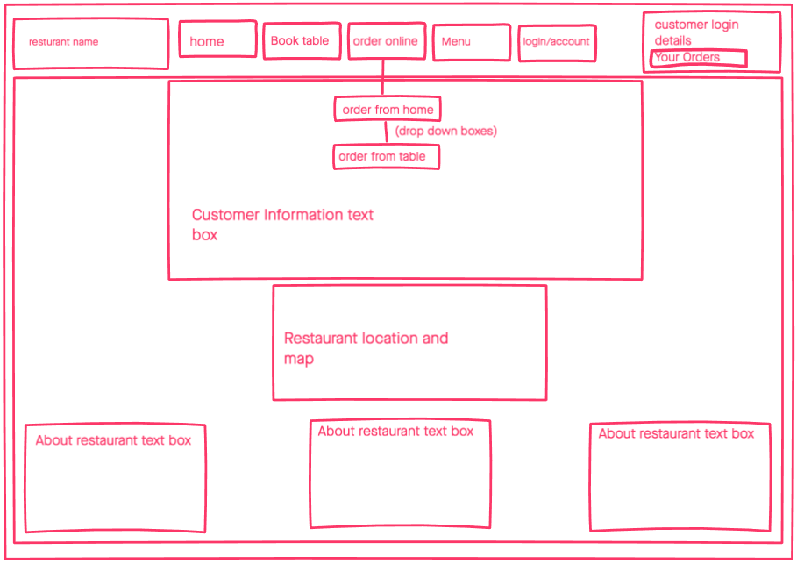

In regard to the services that the system will provide to the user, the online table booking page allows the user to enter their information such as name, date, time and number of people attending with the use of text boxes. The use of text boxes will be displayed for the reservation name where users will be required to enter this field of text in order to book. All dates, times and number of people attending the reservation selection dropdown boxes will be used for the user to select the options. This section is presented as a list on the left side of the page. The right hand side of the page will include images of the restaurant and other general information at the bottom of the page.

Table booking page

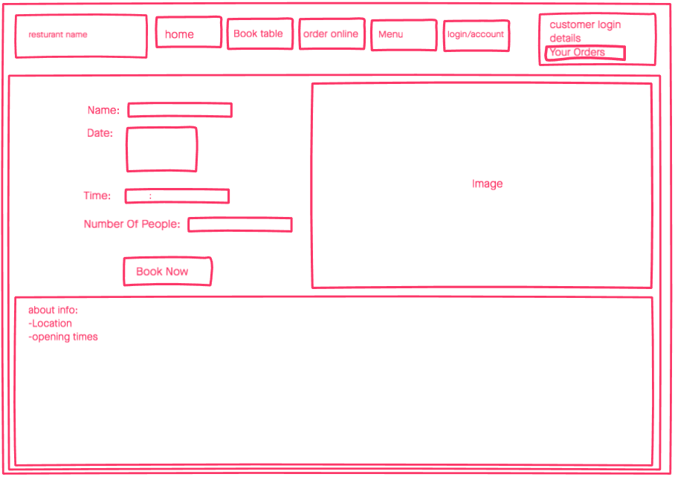

The online ordering option allows all users to order both from a restaurant table and from home. The tool bar at the top of each page has dropdown order online service option, featuring both order from table and order for home delivery options. Both ‘from home’ and ‘from table’ options will have the same page layout, keeping the system design understandable and consistent. These page’s feature four sections on the left side of the page which includes a dropdown menu for starters, main course, dessert and drinks. Under each section, an ‘add to order’ button is displayed where the users will select foods and drinks, then proceed to adding these fields onto the order via the button. All order information is presented on the right-hand side of the page where the user can view the total price. In the bottom left-hand corner of the page, an order comment text box is presented for the users to add any information about ingredients changes. Moving onto the bottom right-hand corner of the page, the checkout button is presented for the users to proceed to paying for their meal. This same layout is used for the delivery booking order page.

order page

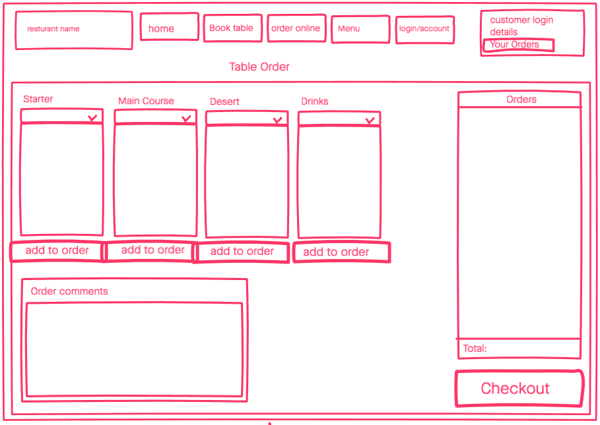

The menu page is listed in four separate sections which are; starters, main course, deserts and drinks. This page contains the greatest amount of information, and the separate sections ensures that it does not overwhelm the user. The menu is laid out across the entire page with the prices matching the food and beverages.

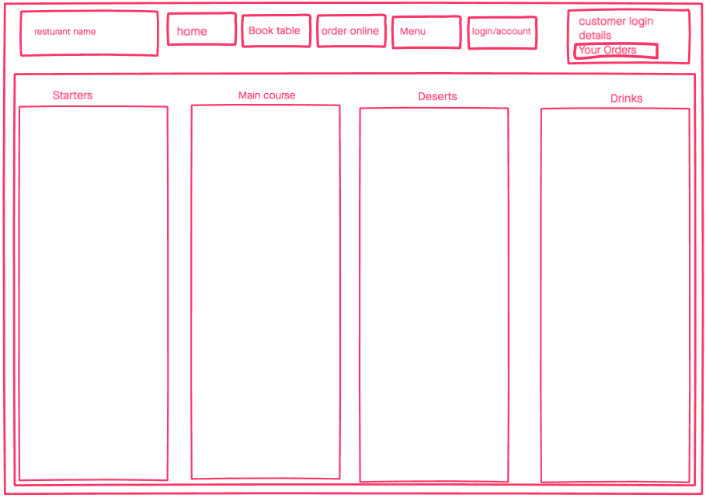

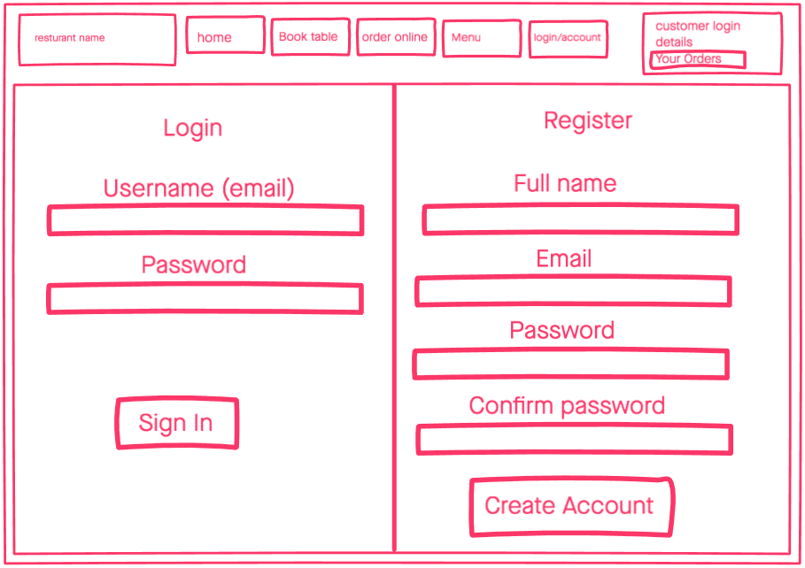The layout for both login and account registration is presented on a single page split in two halves. The login section is set on the left side of this page with a username that includes the users email address and their password. In an ordered fashion, both fields will have text boxes for the user to enter this information, which then they proceed to pressing the ‘sign in’ button below. The register section will be presented on the right side of the page in a listed format, starting from the user’s full name, email address, create password and confirm password. Like with the login section, the registration section will also feature text boxes for the users to enter the field of information, which they will then proceed to pressing the ‘create account’ button underneath.

The online system requires two different checkout pages for both customer in-restaurant and home delivery orders. As this is the final stage of the ordering process, the aim of the design is to attract customers to make future orders. To achieve this, a selection of restaurant food images from the menu are displayed around the page attracting the user’s attention, with the intention of making them hungry for food. For the payment section of the in-restaurant order checkout, the payment fields are presented with the use of text boxes in the centre of the page they require the user to enter their payment card name, card number and CVC code. After the user completes this, they are then required to enter their table number underneath, where they will then proceed to the ‘order now’ button. The same page format is used in the home delivery checkout. The only difference is that this checkout requires the user to enter their delivery address. This is displayed in the same listed format like the payment detail fields, with text boxes for address ‘Line 1’, ‘Line 2’, ‘Town’, ‘Postcode’.

Table order checkouts

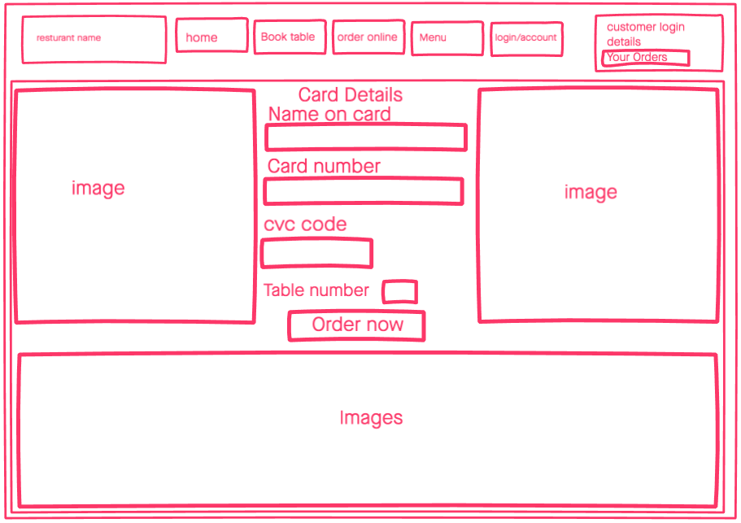

Home delivery checkouts

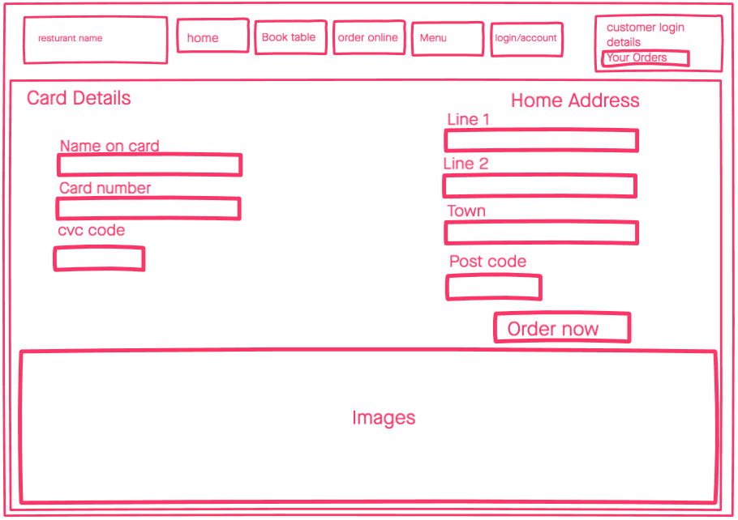

The staff section of the system plays a vital role for the workflow. In order to keep the workers informed and up to date with customer orders for table orders, delivery orders and table reservation bookings, a listed format design has been used. Using a listed format presents the information is a clear manner which can potentially eliminate potential staff confusion issues. This is critical as missing or misplacing orders can lead to poor customer service quality and customer frustration. Each order box has an ‘order complete’ button which is allocated for the staff to press and confirm that the order has been completed.

Staff page

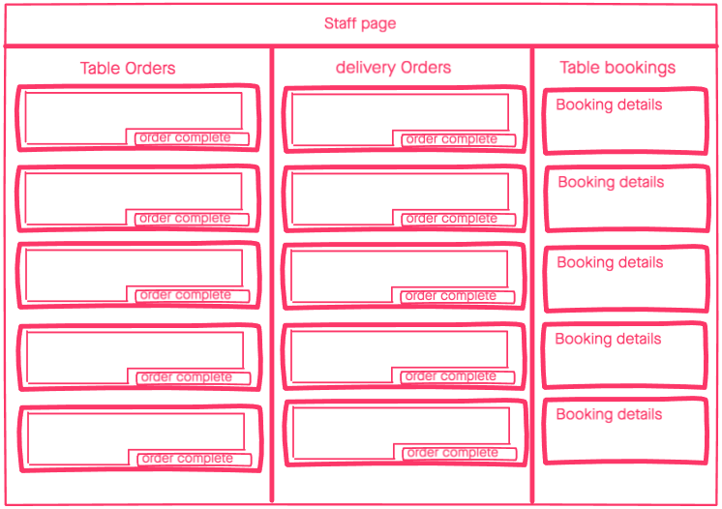

I encountered some design challenges. I designed a home page, taking into consideration the stakeholder’s requirements which were gathered from the stakeholder analysis section of this project. When presenting my prototype to the stakeholder, I received feedback to change the layout of menu information displayed on the page. The stakeholder believed that the home page looked cluttered and needed to be simplified. Instead of having each menu type presented at the bottom of the home page as headers with an image for each, the stakeholder wanted to change this to advertising information about the restaurants traditional foods, delivery offers and cocktail drinks. With this feedback, I redesigned the first set of home page prototypes. I inserted three images at the bottom of the home page with text advertising the stakeholder requirements, and subsequently created buttons for each image which when pressed, directs the user to the full menu page within the system. I presented this prototype to the stakeholder, and the feedback I received was positive. He believed that the home page fulfilled all his criteria in an aesthetically pleasing manner.

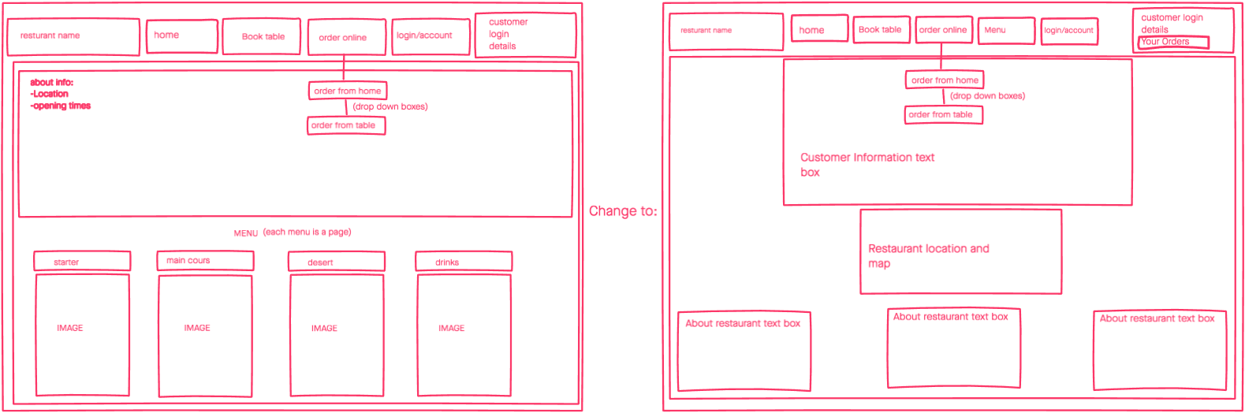

I also encountered some problems with the staff page in my first set of prototypes. When presenting to the stakeholder, he believed that the presentation of the staff page was too disorderly, having the potential to come across as too complicated and overwhelming for the staff to understand. This can become a problem especially during restaurant peak times when large numbers of orders are made by customers, which can lead to confusion and slow customer service. Improvements in customer service and the increase in revenue that comes as a result of this is the priority aim of this project and therefore this problem had to be prioritised and overcome. The feedback received from the stakeholder about this issue was to change the order layout of this page from a column to a row format for both table and delivery orders. This change was made and presented to the stakeholder who approved the layout of the page. It is important to informing the stakeholder during the design process, as it is crucial to receive their feedback in order to create the most accurate design for their business.

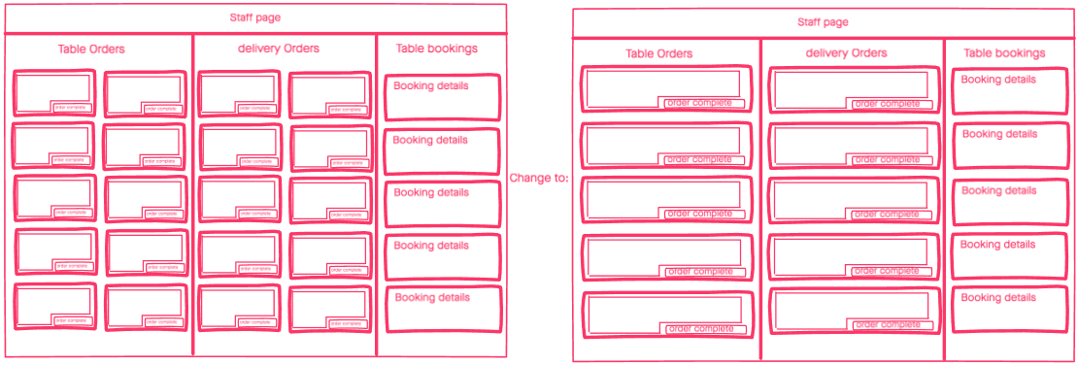

Storyboards have been also been created. Storyboards are graphic organisers which display the illustrations of the user’s actions through images in a sequence. In this case, the images are the prototype wireframes of the system using animations of a user undertaking home delivery orders, table reservations and in-restaurant orders. Storyboards have been used as it is an important step for the production process of the design as it clearly conveys the flow of the system. The user journey detailed within the different steps of the storyboards have been obtained from the style guides above. To view the storyboards, view Figure 2 in the appendix.

In the process of designing the project, a flowchart has been created, with the use of Lucidchart, to examine each process of the online system with its functions. The flowchart visually presents the step by step processes the user will undertake within the system to complete tasks. The chart is built from stakeholder’s requirements within the functional requirements section, alongside system features and the first prototype design as shown above. The diagram created is split into three sections (to view the entire flowchart see Figure 3 in appendix). These sections are login/create account, table reservations and home delivery/table food orders. The homepage is the starting point of the system, and the user will be automatically diverted to the home page after completing orders and booking tasks.

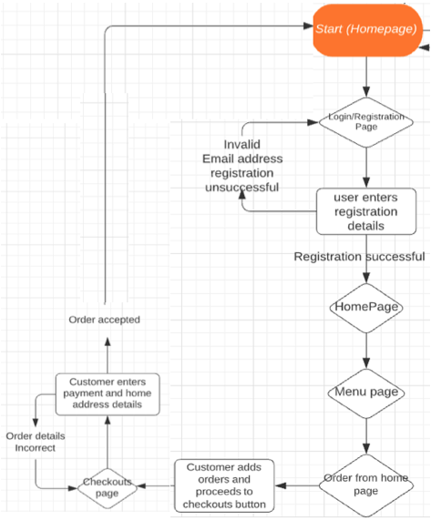The first section of the flowchart shows the process of the user creating an account and making a home delivery order. This process starts from the home page then proceeds to the different functions of the online system. The user proceeds to the login/registration page where they enter their registration details; ‘full name’, ‘email’, ‘password’ and ‘confirm password’. The process of the flowchart shows that if the required email field has been entered incorrectly with an email address that is not recognised after pressing the create account button, then the online system will automatically reload the registration page with an incorrect email field error. However, if the email entered in this field is correct, the system will direct the user to the homepage which will allow them to navigate to the menu page to view menu foods and pricings.

The flowchart then proceeds to the ‘order from home’ option where the user is required to select foods from starter, main course, deserts and drinks options. When these fields have been selected, the user will then proceed to the checkouts via the checkout button on the page. Within the checkouts page, the user is required to enter their payment method details and home address for delivery. The flowchart shows that if the payment method and delivery address details are incorrect, then the online system will automatically reload the checkouts page with an error indicating these field. However, if this is correct, then the system will divert back to the homepage.

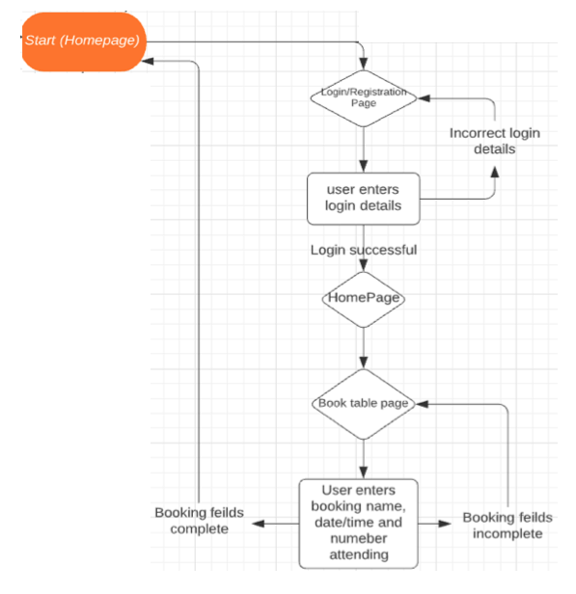The second section of the flowchart shows the process of the user logging into the system and booking a table reservation. Similar to the process of creating an account, when logging into the account, if the user enters incorrect login details, the system will then automatically reload the login page with an incorrect login details error. However, if the login details are correct, then the system will divert the user back to the homepage. From the homepage, the user will then navigate to the book table page via the toolbar to make a reservation. Within the book table page, the user is required to enter their booking details which consists of the booking ‘name’, ‘date’, ‘time’ and the ‘number of people attending’ the reservation. If the booking table fields are incomplete, then the online system will automatically reload the booking page with an empty booking field error. However, if the booking fields are complete, then the system will divert back to the homepage.

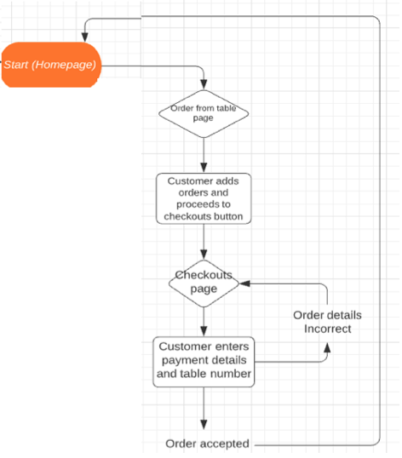

The third section of the flowchart shows the in restaurant food orders. As the system allows home delivery food orders alongside in-restaurant food orders, the in-restaurant orders share the same process as shown on the flowchart. The only difference between them are the checkout details. With the in-restaurant food orders, the checkouts only require the table number and payment details which if entered incorrectly or missed, the system will automatically reload the checkout page with an error indicating these missing or incorrect fields. However, if these fields are entered correctly, the system will divert the user back to the homepage.

After the first set of wireframes were complete and approved from the stakeholder, the final professional wireframes were created. The desired colours, font styles and images were attained previously within the stakeholder feature analysis. This information has been taken into consideration when creating the final set of wireframes. For the full set of wireframes, see Figures 4-12 in the appendix.

The next section speaks about the design of this project by using three of Don Norman’s Principles of Interaction Design; affordance, visibility and feedback. Norman's main idea is that things, such as computers and devices should, be functional, easy to use, and intuitive. Using his principles will showcase how each features of the system were designed in a way that takes into account functionality and ease of use. The visual aids seen below have been attained from the final set of prototypes.

../Screen%20Shot%202020-05-15%20at%2018.28.26.pngThe tool bar at the top of each page enables the user to navigate to each section of the system. The icons in the tool bar display hints and clues about what the user can do on the website, as a result, the toolbar can be viewed as an explicit affordance. The different sections within the toolbar are separated from each other visually through separate boxes which enables the user to view them as buttons for them to select. Moreover, the text within each button helps the user understand where the button will divert; ‘book table’ button suggests that when selecting this button, the user will have the ability to enter their information for table reservations. Additionally, the toolbar is positioned at the top of the page as opposed to the bottom or vertically on the left or right side of the page. The toolbar has been placed here because when the user runs the system, the top of the page is what they will see first, mainly because systems and applications work from the top downwards.

There are various buttons throughout the system, notably the toolbar comprising of buttons seen throughout all pages; the ‘book now’ button on the table bookings page; the ‘add to order’ button and ‘checkout’ button on the order page; the ‘order now’ button on the checkout page; the ‘log in’ and ‘create account’ button within the login/create account page; the ‘order complete’ button within the staff order page. Alternative features that could have been used include underlined links, which were not used mainly because it was felt that it was not suitable for this system, primarily because underlined links are usually not a feature within ordering systems. Additionally, such links are presented in plain text with no particular background or colour, which lack presence on the page. On the contrary, buttons are suitable as they are clearly presented and users are aware of its ability to navigate to the next process of the system.

../Screen%20Shot%202020-05-15%20at%2018.29.34.png../Screen%20Shot%202020-05-15%20at%2018.29.59.png

../Screen%20Shot%202020-05-15%20at%2018.30.18.png../Screen%20Shot%202020-05-15%20at%2018.29.43.png

The restaurant logo is presented on the left side of every page. This presents an immediate hint that the website is affiliated to the restaurant, which is a strong affordance, especially for its loyal customers. Additionally, this logo is also a button which navigates the user back to the home page when on a different page of the system. There are no prompts for the user to explicitly understand the functionality of the logo, therefore the affordance is implicit in nature. However, various systems use this type of logo functionality which has led it to become widely known and a typical prompt. Therefore, users with prior experience of this functionality, will understand and use this function.

../Screen%20Shot%202020-05-15%20at%2018.32.10.png

The website has various drop-down tool bars, otherwise known as combo boxes. This is a way of giving the user options to select various services within a section. An example of this is the ‘order online’ drop down box visually seen within the toolbar on all pages of the website. The drop-down box allows the user to select from two different order services; ‘order from table’ and ‘order from home’. The user understands the drop-down function and how to use it as the drop-down box is displayed with a downward arrow. A drop-down arrow is widely considered as a tool to allow users to make a selection from a list. This therefore prompts the user to explore its function and make a selection to fulfil their order and proceed to checkout. Additionally, an alternative format of displaying the dropdown function would be for the user to simply hover over a displayed menu, and for a drop –down box to immediately appear. That has not been completed as users are likely to use, computers as well as other devises such as mobiles and tablets when using the system. Since ‘hovering’ cannot be completed on mobiles and tablets, this was not included as the features of the system should be consistent.

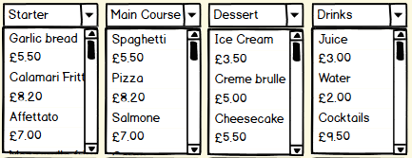

../Screen%20Shot%202020-05-15%20at%2018.34.27.png

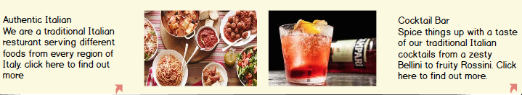The system comprises of images, which can be seen on various pages, specifically the home page, book table page, checkouts and menu page. Whilst all pages showcase simple images for the user to view, the home page displays photos at the bottom of the page advertising different foods and drinks, which when pressed, the user will be directed to the menu page. There is text on these images and the images themselves are buttons that when pressed, direct the user to the menu page. In order for the user to understand the functionality of these buttons, the images have text stating ‘click here to find out more’, which acts as a prompt for the user to press on the image. The phrase is also highlighted in bold which enables it to stand out, making the affordance clear to the user.

The home page accompanies various information, one of which is the restaurant location. The page presents a Google Maps icon which the user is able to press on and directs them to Google Maps via the app (if the user has it) or the webpage. The Google maps image does not indicate that the user should press on the map, via text for example. However, the Google maps icon is relatively small meaning that the user is unable to identify the exact location of the restaurant. Therefore, a user’s natural reaction would be to click on the icon in order to clearly view the location of the restaurant. In this sense, the affordance is implicit in nature. Additionally, the user may have prior experience and knowledge of the use of Google Maps as an icon within other websites and apps, and so pressing on the icon can be very natural for them, as a result the affordance can be considered explicit to some.

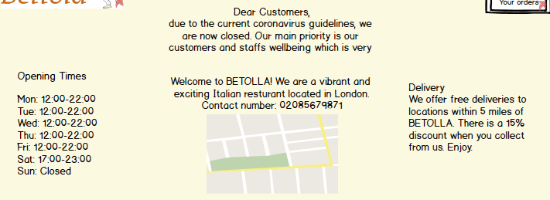

Fields are used throughout the system, specifically on the; ‘book table’ page, ‘order online’ pages, ‘checkouts’ page and ‘login/register’ page. The user understands the need to enter their details, such as card details, email addresses, home address etc., in the fields for various reasons. There is a heading that states the type of information that needs to be entered within the textbooks below, giving the user a prompt for the information required. Also, it’s clear that the field is an interactive element due to their rectangular shape and contrasts with other elements on the page, making it an explicit affordance.

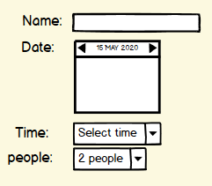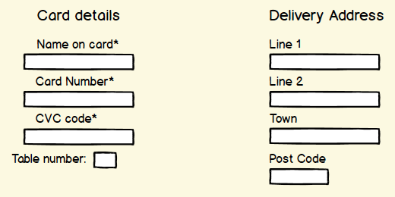

Primary colour:



This colour was chosen for the background as the stakeholder desired a clean, sophisticated colour, however white looked too bland. As a result, cream was chosen as it is a soft colour and not intense for the user.

|  |  |
| --- | --- |
| **Type** | **Value** |
| **RGB** | 252, 255, 224 |
| **HEX** | FCFFE0 |
| **HSL** | 66, 100, 94 |
| **HSV** | 55, 27, 91 |

Secondary colour:

colour

When hovering or clicking on buttons, this is the colour displayed to highlight the action. This colour was chosen as it contrasts nicely with the cream background and black text, and the action that the user takes is made clear.

|  |  |
| --- | --- |
| **Type** | **Value** |
| **RGB** | 158, 196, 230 |
| **HEX** | 9EC4E6 |
| **HSL** | 208, 59, 76 |
| **HSV** | 208, 31, 90 |

**Methodology**

As regular access to the stakeholder was not possible through the development of this project, an agile methodology was not an appropriate method for this design. As a result, the project utilised a big design upfront waterfall style methodology with the use of the stakeholder analysis, where there were too many opportunities for something to be developed that is inappropriate and not fit for purpose to reach the users requirements. Therefore, the methodology was predominantly a big design upfront though divided into two longer sprints where an initial structural prototype then a later professionally designed prototype was informed with stakeholder feedback from the first prototype.

Regarding the wireframe build, InVision was utilised to create the first set of low profile prototypes. The familiarity with the software enhanced the decision to use it; whilst Adobe XD has more features, the familiarity with InVision meant that the project could be completed at a quicker speed. Additionally, InVision presents itself with a very natural user interface, which has similar affordances to sketching with pen and paper, making it a suitable software for developing prototypes. The software allows one to present the prototypes clear style, which is important as my stakeholder must have a clear visualisation of what the website could potentially look like in order to understand whether their requirement have been fulfilled, which enables their ability to provide feedback. Balsamiq was utilised for the final set of professional prototypes. Various UX companies use this particular software for their wireframes, which indicates its professionalism, enhancing the decision to use the software for this project. Additionally, it provides ready to use templates and designs to convert first prototypes into the final set of prototypes.

**Cognitive walkthrough**

For this project, a cognitive walkthrough has been used to test the project design with the stakeholder. A cognitive walkthrough is the method of evaluating the designs usability. It aims to focus on the user’s viewpoint of the design by narrowing down the scope of tasks which needs to be completed to accomplish specific user goals.

Using a cognitive walkthrough within this project design is the correct method of evaluating every step of the processes to the completion of the user goals. It is crucial to evaluate each process of the system with the stakeholder, testing the design and making sure that the design meets all the set requirements from stakeholder analysis. This is different to the likes of a heuristic evaluation, which has not been chosen for this project as it focuses on the design as a whole and not specific tasks that the user undertakes to reach the user goals. Therefore, cognitive walkthrough is a more in-depth and suitable method of testing the design.

A cognitive walkthrough is split into three parts:

1. Identifying the user goals which are to be examined.
2. Identify the task that must be completed to accomplish the user goals.
3. Document the experience when completing the tasks.

In order to carry out the testing, the user goals are identified from the stakeholder’s user stories. The user goals are the primary objectives which are achieved through the step by step tasks undertaken by the user when operating the online system. With the cognitive walkthrough, four goals have been identified from the stakeholder analysis within the user stories, which the user has to complete correctly in order to accomplish the user requirements. These are:

1. Create account/login
2. Book table
3. Order food
4. Checkouts
5. Staff Page

In the below, all possible paths are identified to accomplishing each goal. These paths have been gathered from the first set of wireframes and the flowchart process diagram.

Goal: Create account/login

* Open Bettola web page
* Click on ‘login/create’ account button in the toolbar
* Enter registration ‘name’, ‘email’, ‘password’ and ‘confirm password’ fields
* Click ‘register’ button to create account
* Enter login details including user ‘email’ and ‘password’
* Click ‘sign in’ button

Goal: Book table

* Click on the ‘book table’ button in the toolbar
* Enter booking ‘name’, ‘date’, ‘time’ and ‘number of people attending’ fields
* Click ‘book now’

Goal: Order food (both in-restaurant and home delivery)

* Click on ‘order online’
* Click on each menu dropdown box which include ‘starter’, ‘main course’, ‘desert’, and ‘drinks’
* Add food and drinks from each menu option
* Click on the ‘add to order’ button after selecting each menu
* Click on ‘checkouts’ button

Goal: Complete checkouts for in-restaurant order

* Enter checkout details ‘name on card’, ‘card number’, ‘cvc code’ fields
* Enter table number in the textbox field
* Click ‘order now’

Goal: Complete checkouts for home delivery order

* Enter checkout details ‘name on card’, ‘card number’, ‘cvc code’ fields
* Enter home address details ‘line 1’, ‘line 2’, ‘town’, ‘post code’
* Click ‘order now’

Goal: Complete order process in staff page

* View delivery orders, in-restaurant orders and table bookings
* Click ‘Order complete’

The experience users undertake when completing the systems tasks is a subjective factor. It is important to structure and evaluate the walkthrough with the stakeholder in order to see if their criteria’s have been met. As a result, a set of questions have been created to evaluate the design which the stakeholder is required to answer during each task. The questions were decided on the functionality and structure of the design, testing the process and the systems feedback to see if the user goals have been met. These questions are[2]:

1. ‘Does the user understand how to start the task’?
2. ‘Are the controls noticeable’?
3. ‘Will the user know the control is the correct one’?
4. ‘Was there any feedback to indicate that you completed or did not complete the task’?
5. ‘Feedback notes’

The questions that were asked during the test were answered in a ‘Yes’ and ‘No’ format where the stakeholder then gave their feedback through notes for each goal. The first question analyses whether the user understands the task within the test. This is done through the clearness of the function and process with the use of information, buttons and text box fields presented for the user to use. Question two analyses the clarity of the buttons, information and text box fields to see if it is clear to the user on the page. The third question analyses if the user understands what each functions control is on the page. An example of this from the design section is the buttons which highlight blue when the clicker hovers or presses it to indicate that this is a button. The fourth question analyses the feedback of the functions within all pages, for example when the user selects a button in the toolbar the feedback will navigate the user to that section of the system. Finally, the fourth question allows the stakeholder to give feedback notes for each process within the testing. To view the test results, see Figure 13 in the appendix.

Overall, the testing proved that the system design met the stakeholder’s requirements both through the user requirements and presentation of the system. The stakeholder commented that the testing questions in coloration to the testing paths answered correctly to reaching the user goals.

**Critical analysis**

The aim of this project was to design an online automated system to the restaurant Bettola, which was fulfilled. The aim was achieved through various objectives outlined at the beginning of this project. This critical analysis will highlight the objectives and discuss and analyse how they were achieved, highlighting accomplishments and drawbacks faced.

The first objective was to research how customer service inefficiencies could be overcome and the subsequent result that comes from this, specifically the increase in a restaurant’s revenue. This was accomplished through the literature review. The conclusion derived enhanced my understanding of restaurants and how they should operate, giving me background knowledge and context for designing the automated system for Bettola. It enabled me to understand that self-service cannot operate exclusively within restaurants, especially small restaurants like Bettola, as customer relationships create loyal customers and a subsequent increase in profits.

The next object was to conduct stakeholder analysis through a questionnaire to gain an insight into how the business is run, the problems Bettola is facing and their requirements for an online system. This was fulfilled through the use of a questionnaire, which enables me to to gain data for the development of functional and non-functional requirements. However, regular access to the client was not provided, due to the complications of both my university timetable and the stakeholders workload. Furthermore, the Covid-19 pandemic worsened these factors. As a consequence, I was required to adapt my waterfall method that I was originally planning on undertaking into a big design upfront waterfall style method. Having regular access to the stakeholder would have enabled a face to face interview, allowing a more extended and in-depth discussion about the system requirements. However, adjustments had to be made, specifically the development of a questionnaire for the stakeholder. Whilst there was a preference for an interview, the questionnaire was very detailed and allowed me to have a thorough view of the requirements.

Once user requirements were obtained, the next objective was to design a prototype for the stakeholder to analyse, which was also achieved. However, the process was not clear cut. Specifically, when presenting the first set of prototypes to the stakeholder, feedback was given to change the layout of the homepage. The stakeholder believed that the page was not well presented and had an overload of information. Layout issues were also seen within the staff page; the orders on the page were not displayed clearly, impacting the usability. The feedback received was incredibly useful as it enabled the improvement of the system and allowed me to further grasp the user requirements as well as enhancing my understanding of the stakeholder’s likes and dislikes. This meant that upon correcting the layouts and presenting the second set of initial prototypes to the stakeholder, they were approved of. Therefore, the next objective, the implementation of design changed, was fulfilled thereby allowing the move to the next objective; building the final prototypes to then present to the stakeholder. Whilst the first set of prototypes established the structure of the system, the final prototypes established the design of the pages through different colours and fonts. A discussion with the stakeholder allowed the decision of the colours and fonts to be made. This was then implemented into the professional wireframes and approved of by the stakeholder.

Throughout the design section of this project, good use of the client’s time was made, especially especially from attaining feedback about the prototypes. I made sure to send the stakeholder a copy of the prototypes to view before our call in order to give them time to generate feedback and ideas for the discussion. Additionally, some issues were encountered when designing the wireframes. I encountered problems with Adobe XD, a software I wanted to use for my final professional prototypes. I initially wanted to utilise the programme because of its professionalism, however due to Covid-19 and its impact I was unable to access the software through the university computer. In addition, I also faced difficulties when accessing the university network via VMware Horizon Client from my personal desktop due to the magnitude of users utilising the software. I faced difficulties when trying to install Adobe XD on my desktop as the software was not compatible with my desktop, which led to it crashing. To overcome this problem, research was conducted on alternative wireframing software’s and I came across Balsamiq, a widely used software used in professional settings. I found the software user friendly and it allowed me to create professional and original final wireframes.

The next objective was to conduct user testing with the stakeholder to ensure the functions of the system has met the stakeholder’s requirements. This was accomplished through a cognitive walkthrough, which analysed the paths needed to complete the system goals. This allowed me to thoroughly analyse the whole system with the stakeholder and the questions set analysed the both the functionality, the design and the structure of the system design. The stakeholder approved the testing as it met all the requirements.

Upon completion with the benefit of hindsight, there are elements of this project that could have been completed differently. Time management could have been improved, more specifically the stakeholder analysis could have been completed at an earlier stage in order to allow for more time to design the prototypes. However, factors such as my university modules slowed down the process of the stakeholder process.

There are further things that can be completed to extend and develop this project. Specifically, the system that has been designed can be built for Bettola. It would then be very interesting to conduct some research into whether the system has a positive impact on customer service, and more importantly the increase in restaurant revenue.

**Conclusion**

In conclusion, the aim of this project, which was to design an online automated system to the restaurant Bettola, was fulfilled. With the guidance of the stakeholder analysis, the initial set of prototypes were able to be establish and then created into final professional prototypes. Collecting data and presenting it visually was a main component of this project. Flowcharts were presented in order to illustrate the process of the design whilst storyboards were also implemented to showcase the process from a user perspective. The stakeholder analysis alongside flowcharts and storyboards resulted into a positive stakeholder feedback from the testing conducted. As a result, the system fulfilled all the requirements that the stakeholder desired.

Designing this system is a step forward into fulfilling the main aim for the restaurant. Consequently, this system is a step in the right direction to improve the inefficiencies that Bettola is facing, which are slow customer service and long waiting times especially at busy times of the day, and subsequently achieve the main aim of the restaurant which is to increase revenue.

**Bibliography**

Business Insider (2017) “McDonald's desperately needs to fix one of the most annoying things about visiting”.

C.-J. Wu, R.-D. Liang (2009) “Effect of experiential value on customer satisfaction with service encounters in luxury-hotel restaurants”. International Journal of Hospitality Management. 28 pp.586–593.

Cronin, J.J. and Taylor, S.A. (1992) “Measuring service quality: a re-examination and extension”. Journal of Marketing. Vol. 56 No. 3, pp. 55-68.

Dabholkar, P.A., Thorpe, D.I. and Rentz, J.O. (1996) “A measure of service quality for retail stores: scale development and validation'”. Journal of the Academy of Marketing Science, Vol. 24, Winter, pp. 3-16.

Eat (2019) ‘The 9 Best Online Restaurant Reservation Systems Compared’.

Forbes (2019) “Self-Order Kiosks Are Finally Having A Moment In The Fast Food Space”.

Gilbert, G.R. and Veloutsou, C. (2006). “A cross-industry comparison of customer satisfaction”. The Journal of Services Marketing, Vol. 20 No. 5, pp. 298-308.

Gilbert, G.R., Veloutsou, C., Goode, M.M.H. and Moutinho, L. (2004) “Measuring customer satisfaction in the fast food industry: a cross-national approach”. The Journal of Services Marketing, Vol. 18 No. 5, pp. 371-83.

Groovehq. (2019) “Why is Customer Service Important? 11 Ways Customer Satisfaction Correlates with Business Results”.

Jain, S.K. and Gupta, G. (2004). “Measuring service quality: SERVQUAL vs. SERVPERF scales”. VIKALPA. Vol. 29 No. 2, pp. 25-37.

Jee Ahe Ahn, A, J., Seo, Soobin (2018) “Consumer responses to interactive restaurant self-service technology (IRSST): The role of gadget-loving propensity”. International Journal of Hospitality Management. No. 7, pp.109-121.

Johnston, R., & Kong, X. (2011). “The customer experience: a road-map for improvement”. Managing Service Quality. 21(1), 5–24.

Lai, Y-L and Chang, S-C (2013). “How Improving the Customer Experience Quality and Business Performance? A Case Study by Mystery Shopper Practices”. International Journal of Marketing Studies; Vol. 5, No. 6, pp.52-61.

Lemke, F., Clark, M., & Wilson, H. (2010). “Customer experience quality: an exploration in business and consumer contexts using repertory grid technique.” Journal of the Academy of Marketing Science, 39(6), 846–869.

McDougall, G and Levesque, T. (2000). “Customer satisfaction with services: putting perceived value into the equation”. Journal of Services Marketing, 14(5), 392-410.

Olorunniwo, F., Hsu, M.K. and Udo, G.J. (2006). “Service quality, customer satisfaction, and behavioral intentions in the service factory”. Journal of Services Marketing, Vol. 20 No. 1, pp. 59-72.

Parasuraman, A., Berry, L.L. and Zeithaml, V.A. (1991b), “Understanding customer expectations of service”. Sloan Management Review, Vol. 39, Spring, pp. 39-48.

Peter, P., Churchill, G.A. Jr and Brown, T.J. (1993). “Caution on the use of difference scores in consumer research”. Journal of Consumer Research, Vol. 19, pp. 655-62.

Qin, H and Prybutok, V. R. (2009) Service quality, customer satisfaction, and behavioural intentions in fast-food restaurants. International Journal of Quality and Service Sciences, Vol. 1 No. 1, pp. 78-95.

Schere, A., Wünderlich, N, V., Wangenheim, Florian. (2015) “The value of self-service: long-term effects of technology-based self-service usage on customer retention”. MIS Quarterly. Vol. 39 No. 1, pp. 177-200.

Selnes, F., and Hansen, H. 2001. “The Potential Hazard of Self- Service in Developing Customer Loyalty,” Journal of Service Research (4:2), pp. 79-90.

Sulek, J.M., Hensley, R.L., 2004. “The relative importance of food, atmosphere, and fairness of wait: the case of a full-service restaurant”. Cornell Hotel and Restaurant Administration Quarterly 45 (3), 235–247.

Teixeira, J., Patrício, L., Nunes, N. J., Nóbrega, L., Fisk, R. P., & Constantine, L. (2012). Customer experience modeling: from customer experience to service design. Journal of Service Management, 23(3), 362–376.

van Dyke, T.P., Prybutok, V.R. and Kappelman, L.A. (1999), “Cautions on the use of the SERVQUAL measures to assess the quality of information systems services”. Decision Sciences, Vol. 30 No. 3, pp. 877-91.

**Appendix**

Figure 1: Stakeholder analysis questionnaire:

**How do you currently manage your business as a whole?**

At this current stage, I manage my restaurant business manually through pen and paper where my staff take customer orders. All orders are then registered on the till which are then transferred to an Excel spread sheet where I keep track of all orders and profits within my business. My table bookings are currently managed through phone calls. Customers call the restaurant to make bookings, and my staff take a note of the customer name, date, time of booking and the number of people attending in a booklet allocated next to the till.

**What are your main customer complaints about your restaurant?**

The customer complaints I receive is mostly in regard to the timing of the service. This occurs at peak times during the day, for lunch and dinner. The problem I encounter is that my staff cannot keep up with all the customer orders, which results in customers feeling left out, ignored and agitated because of the slow service. Another complaint I come across is missed customer phone calls for table bookings. This tends to happen during peak times throughout the day when the restaurant is busy and phone calls are missed by my staff, which then results to poor reviews and complaints.

**What kind of online system would you like to introduce to your restaurant and why?**

I would like to introduce an online website with services available to the customer such as ordering food online at their own time whilst sat at a table, booking tables online, the ability to view the menu online and a home delivery service. The reason behind this stems from my desire to move from an old fashioned, slow customer service restaurant, which I currently have, to an online and quick method of service, engaging my staff and customers digitally within the business.

**What is your ultimate goal to introducing a new online system from your restaurant?**

Ultimately, I would like the online system to decrease complaint numbers and increase restaurant profit. I expect the online system to decrease the number of complaints I receive, especially in regard to lack of service efficiency. Quicker service will allow me to enhance customer satisfaction. I would also like the online service to reach a wider and larger customer range, through the use of offers and home delivery methods, which will increase the number of customers and therefore increase restaurant revenue.

**What areas of your business currently would you like a new online system to improve?**

The main reason for the website is to improve customer interaction and service.

The website will allow customers to take control of their orders, helping expand and improve the service within the business to therefore reduce the number of customer complaints. Therefore, the focus of the website is centred around the customers inside the restaurant as slow service at peak times results in poor customer service. This website will therefore help improve customer’s satisfaction through better quality service which will therefore have a positive impact on the restaurants timing and interactions with customers, which should directly improve revenue and profits.

**How do you currently manage your business receipts and what would you like to change about this?**

I currently use Excel for my business receipts. All orders are transferred from the till to an Excel spreadsheet. This method is currently working efficiently for orders made through my staff as I can calculate all profits made at the end of the day. However, this method will not work when introducing the online system where payments will be made both in the restaurants and online (for customers ordering home delivery and from the table). Therefore, as well as obtaining information from the tills and transferring it to Excel, I would also like online order receipts to be sent to my business email.

**How do you currently manage your restaurant orders, what would you like to change about this and how do you think this will impact your business?**

My staff are currently taking orders manually through pen and paper. My staff normally approach a customer asking them for their drink order around … minutes of customers sitting down, and then approach them … minutes after that for their food order. Whilst this is a fairly standard approach utilised in many restaurants, at times the customers are not ready to order, and therefore my staff have to approach the customer again at a later point, where they are either ready to order or are still indecisive. When this happens, approaching customers several times can make them feel slightly agitated, which I dislike. Additionally, I experience the most amount of complaints about service during peak times in the day. Due to the high volume of customers entering the restaurant,

By introducing an online system, I would like to change the ordering pattern and split the customer orders by giving them an option to order online at their own time from their table. This will help increase the service speed of my restaurant keeping customer satisfaction rates high and therefore have a positive impact on the financial side of my restaurant. As a result, I want to create a system where customers are free to order in their own time, and only ask for my staff if and when they feel the need to, for food recommendations for example. Consequently, I want a system where the customer has greater control in their dining experience.

**How do you currently manage your delivery orders, what would you like to change about this and how do you think this will impact your business?**

At the moment, I have no delivery service available at my restaurant, however I would like to introduce an online delivery service using the website. In order to this, I would like an additional delivery order page on the website allowing my customers to order food from home. Therefore, customers that are not willing to attend the restaurant have the option to order from home. This additional channel has the potential to expand my business as I predict that we will have an increase in customers and orders which will increase profits for my restaurant.

**How do you currently manage your table bookings and what would you like to change about this and how do you think this will impact your business?**

I currently manage my table bookings through a phone service where my customers call my restaurant, and my staff book the tables according to my customers preferences. This method of table bookings can sometimes be a problematic especially during peak times where staff are unable to pick up phone call. This therefore means that those customers that made the phone call which was left unanswered are less likely to enter the restaurant, meaning that I lose out on profits. To change this, I would like to introduce an online table booking service for my customers to be able to book tables through the restaurant website which will help make the management workflow more flexible and efficient for my staff. I know that it is important to let my loyal customers as well as new customers know about this new service. When the service is implemented, I intend to leave an automatic phone message when a customer calls, informing them of this service. If the customer still decides to book a table over the phone, my staff can easily log into the website themselves and book the table in the same way that a customer would do so. This also means that I am giving the customer multiple ways to book a table, but actively encouraging them to start booking tables online. Due to the multiple ways of booking tables, there is a greater chance that customers will be able to book tables and attend my restaurant, which therefore positively impacts my profits.

**How do you currently manage your restaurant offers, what would you like to change about this, and how do you think this will impact your business?**

I currently manage my restaurant offers through poster adverts viewed inside and outside my restaurant, this means that my customers are not aware of my offers until they are physically in my restaurant. This simplistic method does not actively attract new and existing customers. Additionally, offers are not displayed to a wider audience meaning that the number of new customers entering my restaurant. Offers can be used as an incentive to attract new customers, however my current method of advertising my offers simply cannot reach a wide audience, therefore I have a limited number of new customers entering my restaurant. This may partly be the reason why new customers has been at standstill for many years now.I would like to change this by introducing online offers which will be displayed on the restaurant’s website. I would like this to be clearly advertised on the website’s home page so that it is one of the first things that customers view. Also, users will use their email addresses to register their account on the restaurant website, and I would like to use those emails to send offers via email to all registered users. This means that they do not have to log in directly to the website in order to look for offers. This new method has the potential to reach a wider audience, which I believe will increase my number of customers, thereby increasing profits.

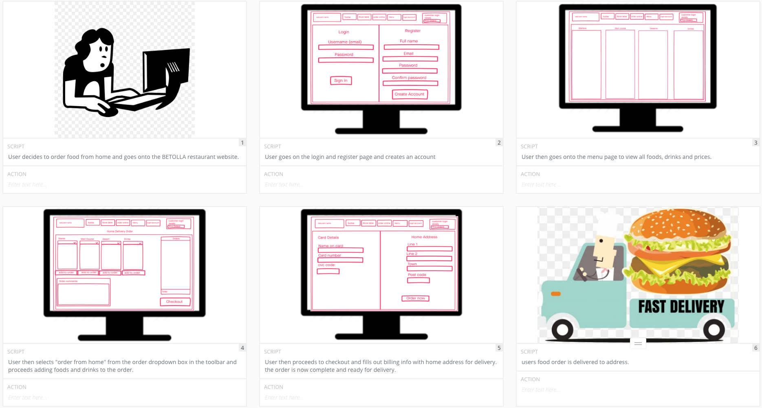Figure 2. Storyboards:

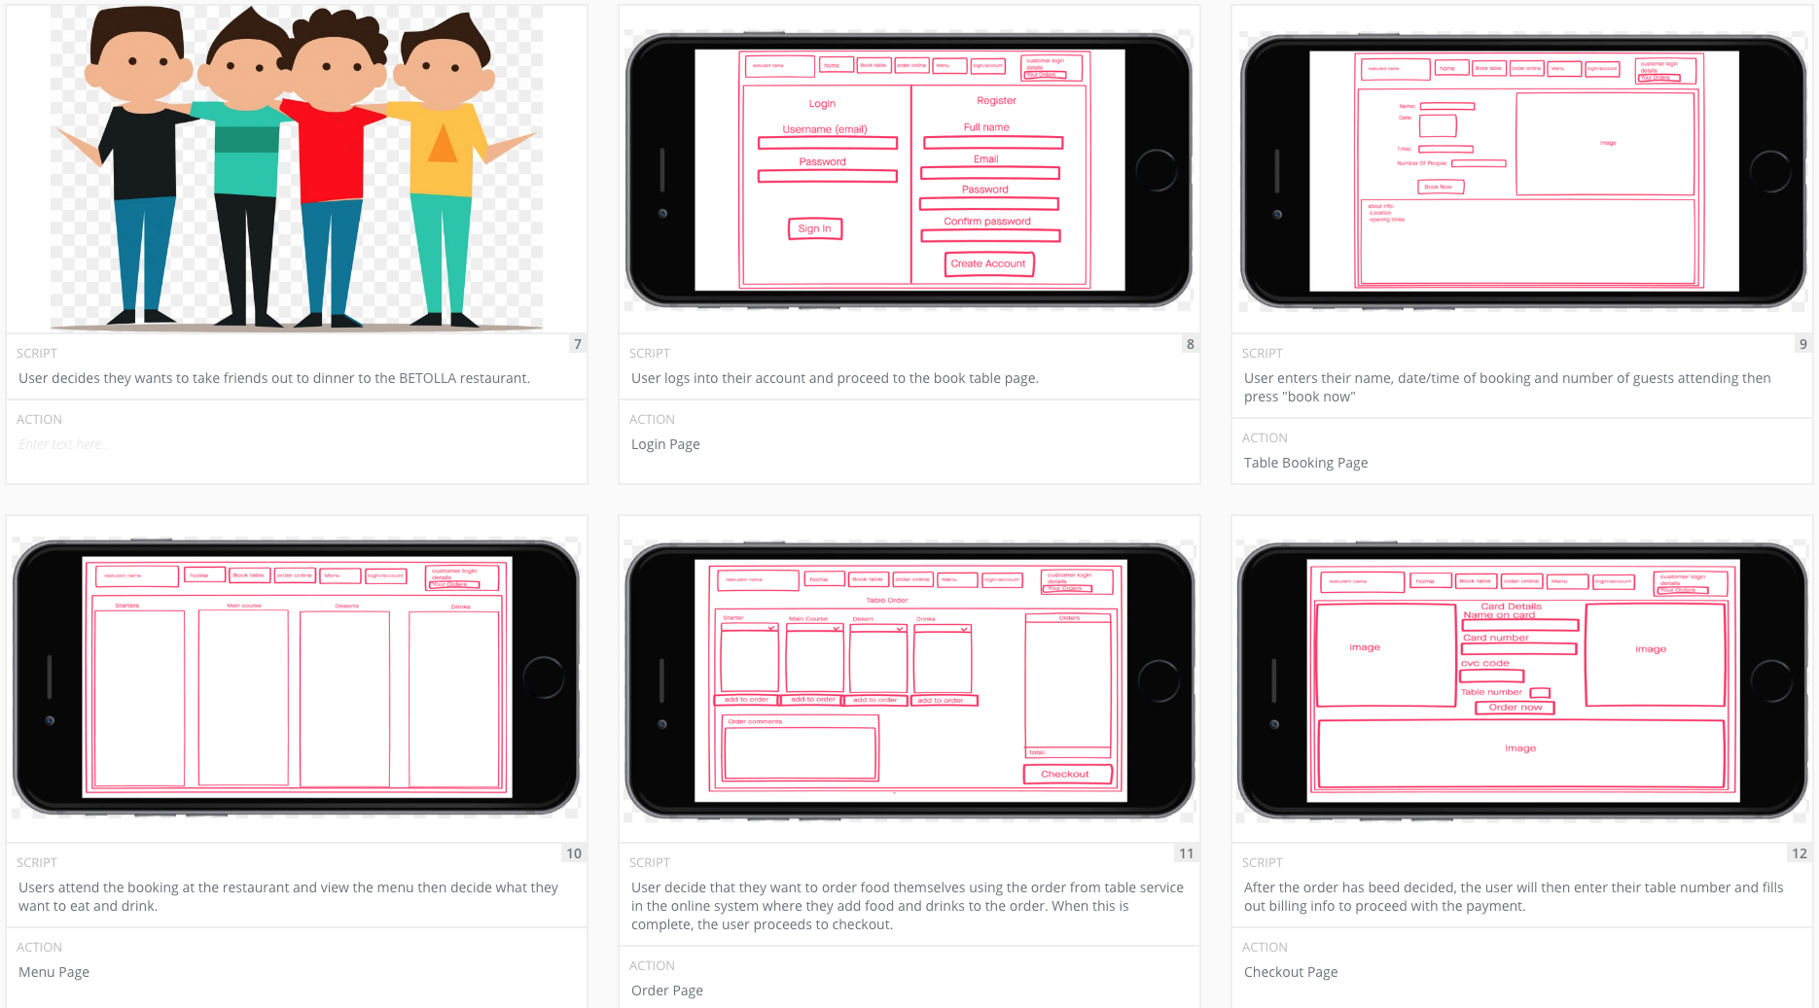

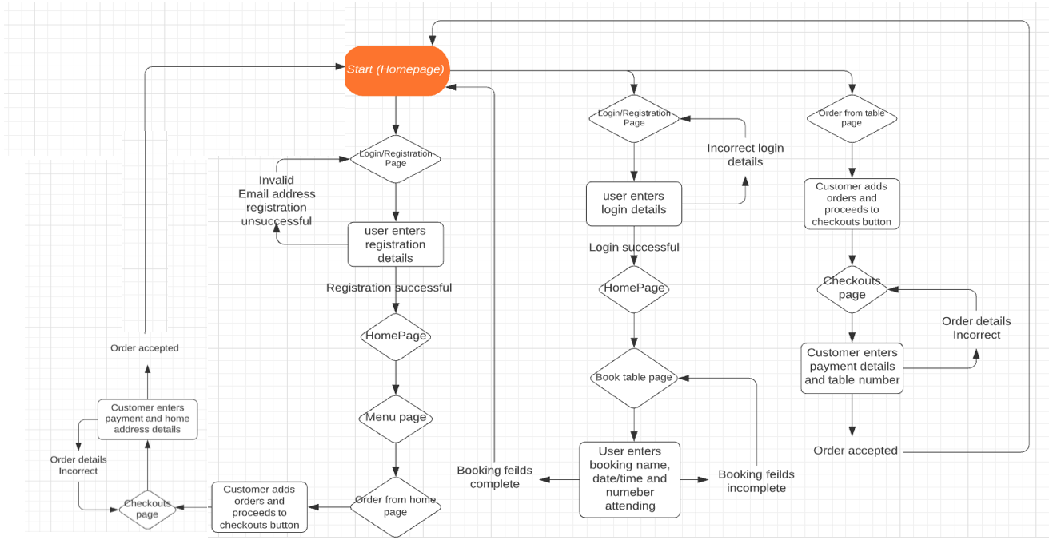Figure 3. Flowchart:

Figure 4: Final Prototype Wireframe. Homepage:

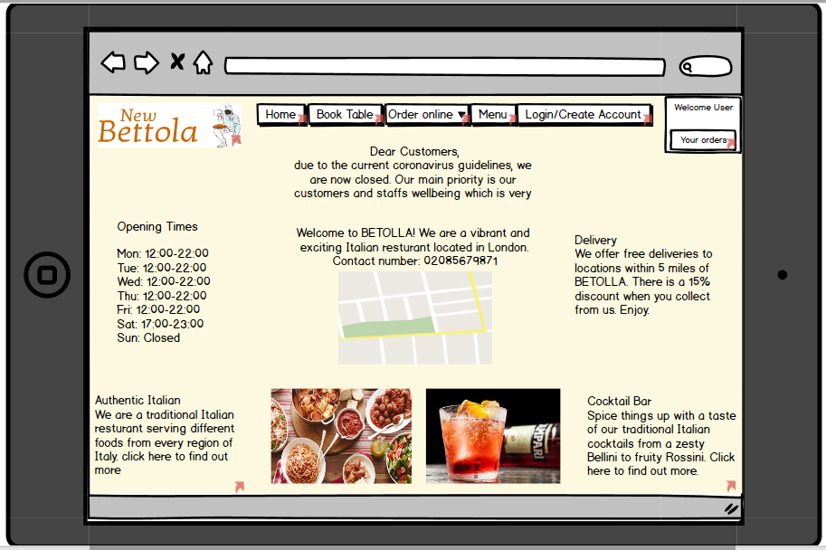Figure 5. Final Prototype Wireframe. Table booking page:

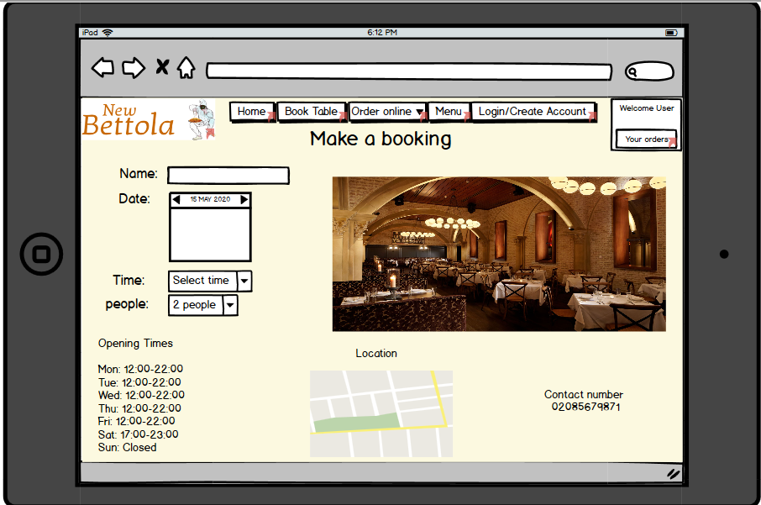

Figure 6. Final Prototype Wireframe. In-restaurant order page:

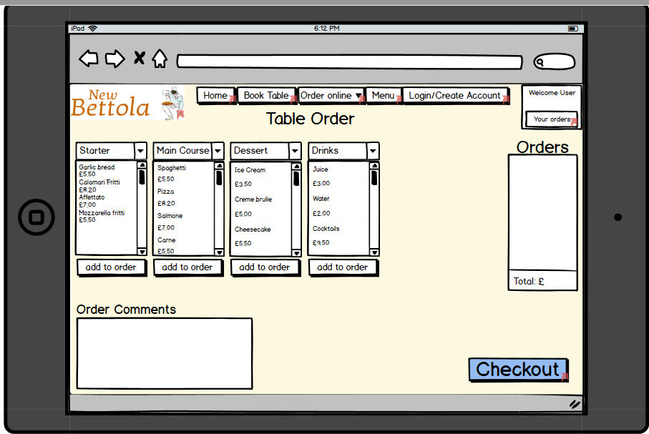Figure 7. Final Prototype Wireframe. Delivery order page:

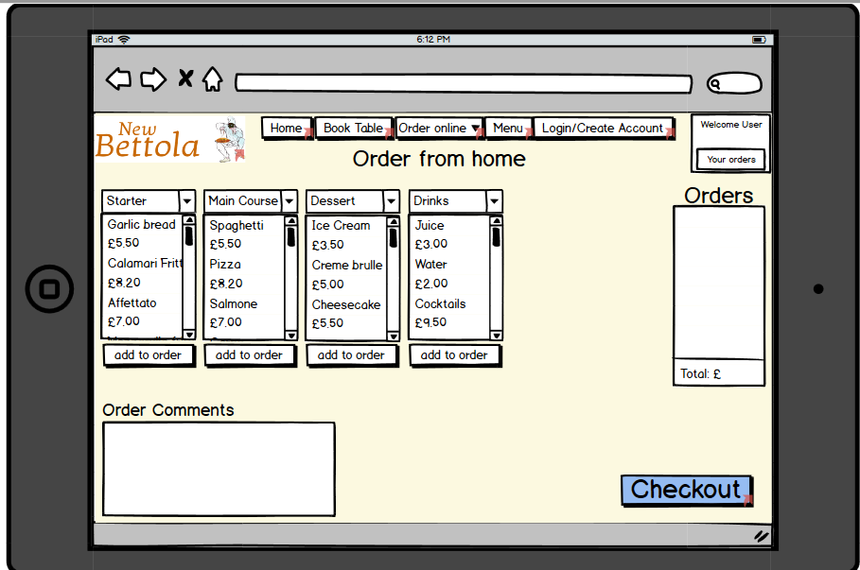

Figure 8. Final Prototype Wireframe. In-restaurant checkout page:

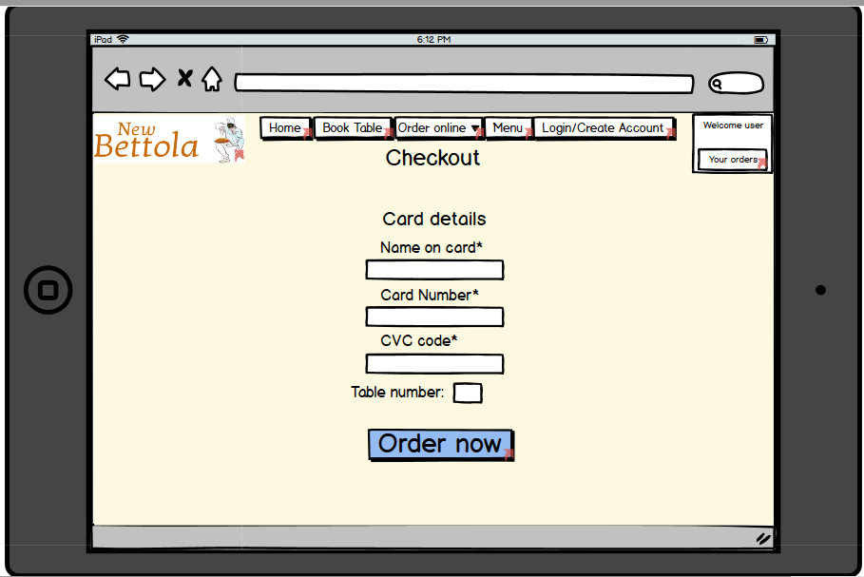

Figure 9. Final Prototype Wireframe. Delivery order page:

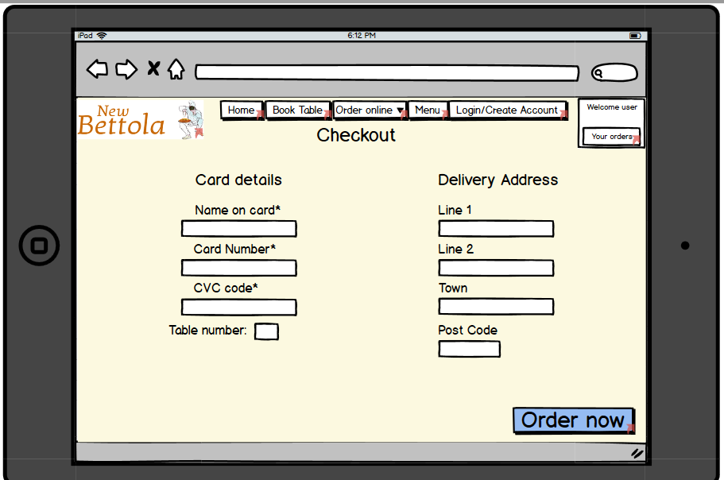

Figure 10. Final Prototype Wireframe. Menu page:

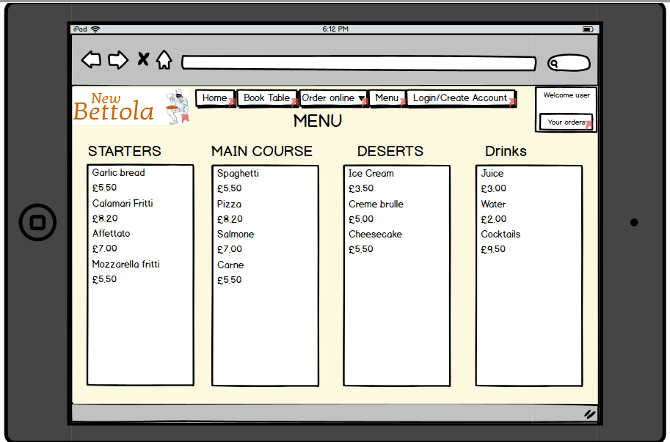

Figure 11. Final Prototype Wireframe. Login/create account page:

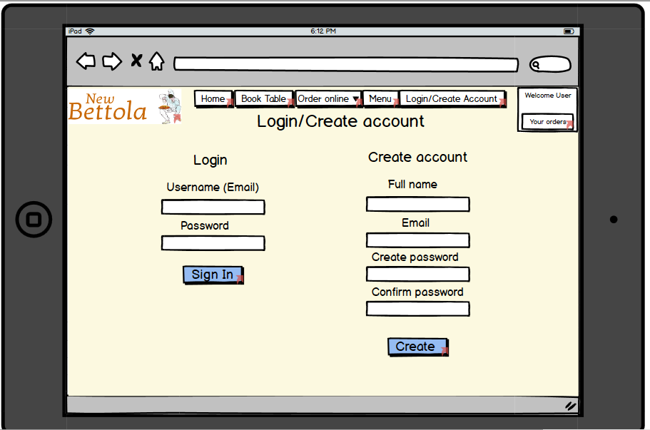

Figure 12. Final Prototype Wireframe. Staff page:

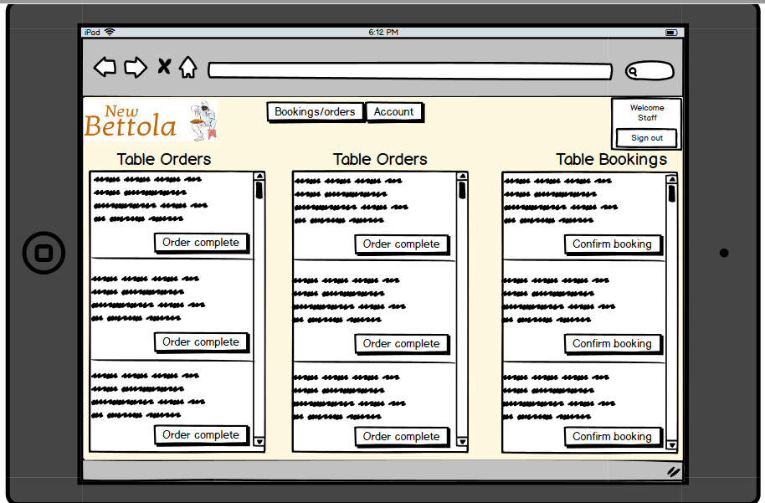

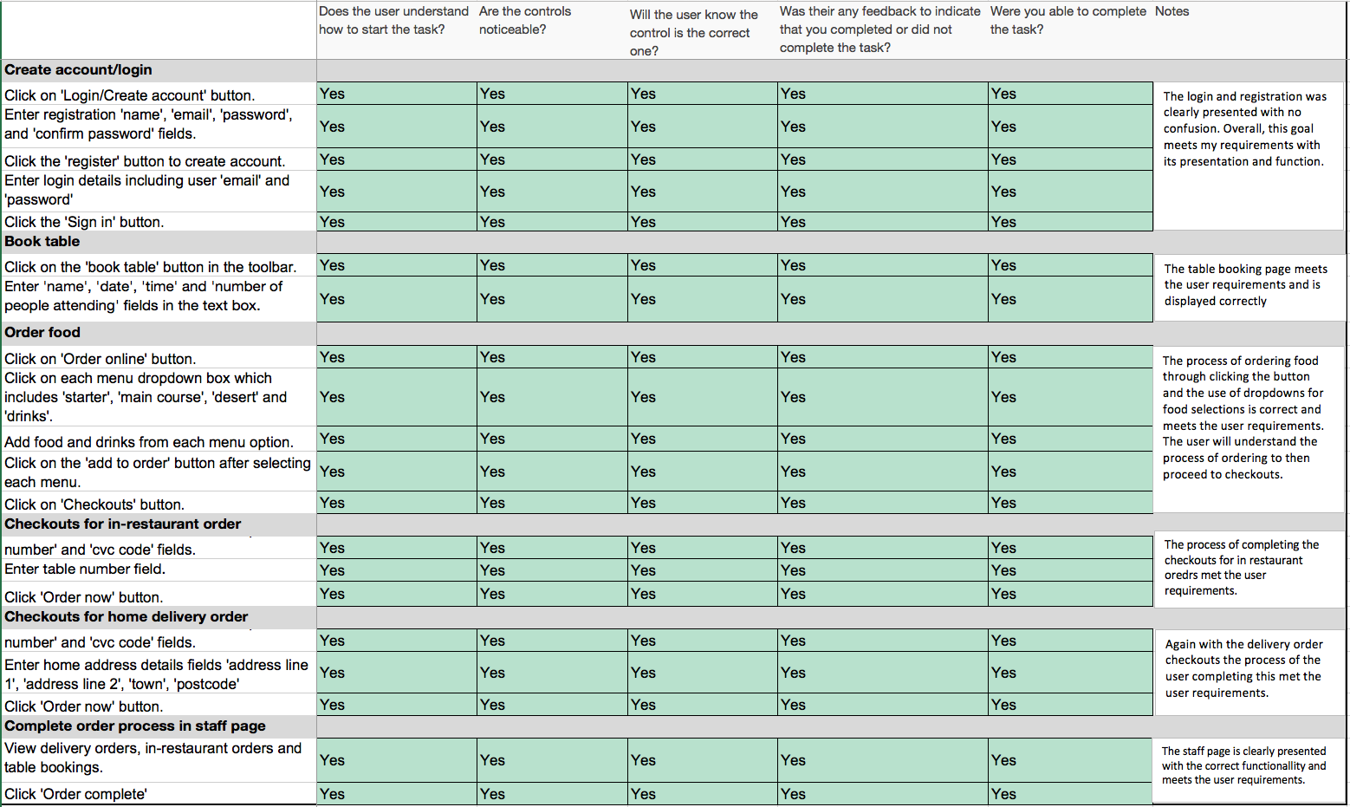Figure 13. Cognitive Walkthrough testing:

1. <https://www.impactbnd.com/blog/the-importance-of-website-load-time>
2. Medium, 2018 (access here: https://medium.com/user-research/cognitive-walkthroughs-b84c4f0a14d4)